Internet of Things Using Home Automation
Description:
WeMos D1 Mini is a powerful internet-enabled development board. This small development board uses one of the most popular and cost-effective Wi-Fi microchip ESP8266, making it a perfect choice for any beginner-level internet of things projects.
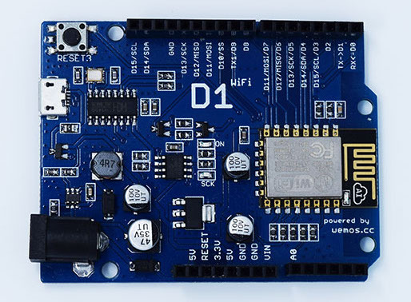

WiFi ESP8266 Development Board WEMOS D1. WEMOS D1 is a WIFI development board based on ESP8266 12E. The functioning is similar to that of NODEMCU, except that the hardware is built resembling Arduino UNO. The D1 board can be configured to work on Arduino environment using BOARDS MANAGER.
Specification:
- Microcontroller: ESP-8266EX
- Operating Voltage: 3.3V
- Digital I/O Pins: 11
- Analog Input Pins: 1
- Clock Speed: 80MHz/160MHz
- Flash: 4M bytes

Requirments:
- Arduino Wemos D1 (ESP8266)
- 4 Channel Relay
- 9V Adapter
- External Power (240VAC)

Relay:
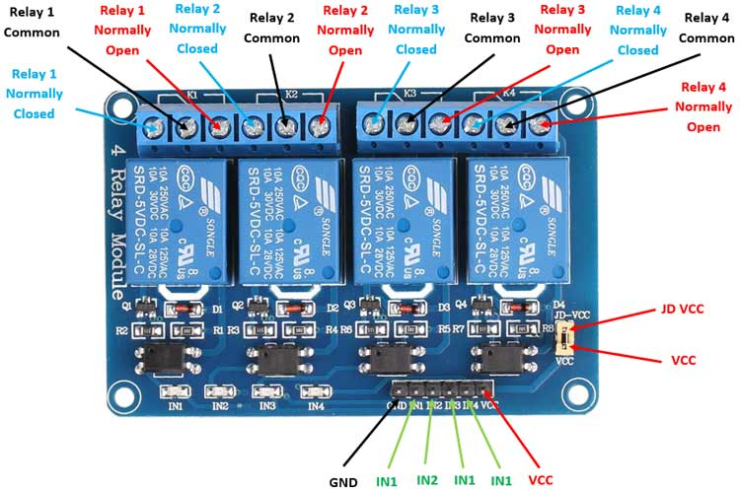
The Relay Module is a convenient board which can be used to control high voltage, high current load such as motor, solenoid valves, lamps and AC load. It is designed to interface with microcontroller such as Arduino, PIC and etc. The relays terminal (COM, NO and NC) is being brought out with screw terminal.
Circuit Diagram: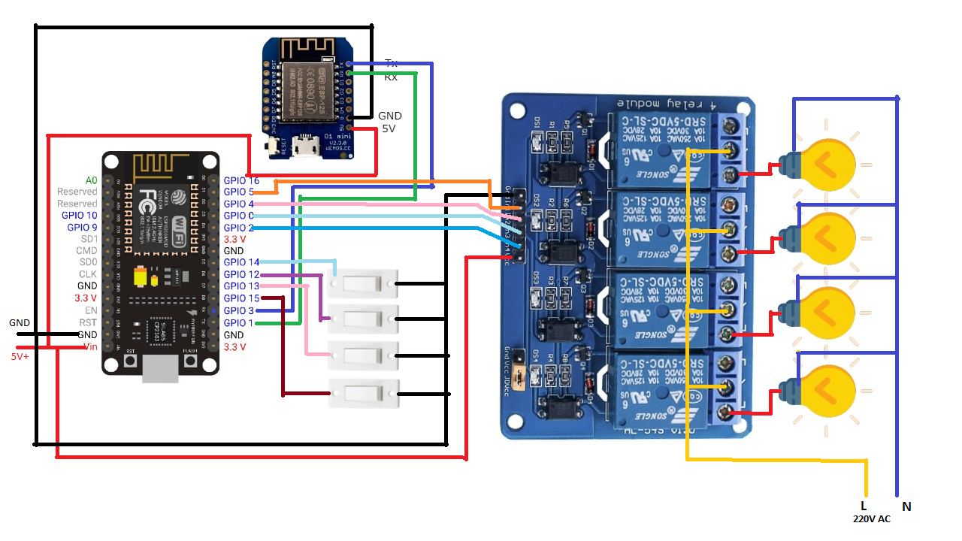
Program:
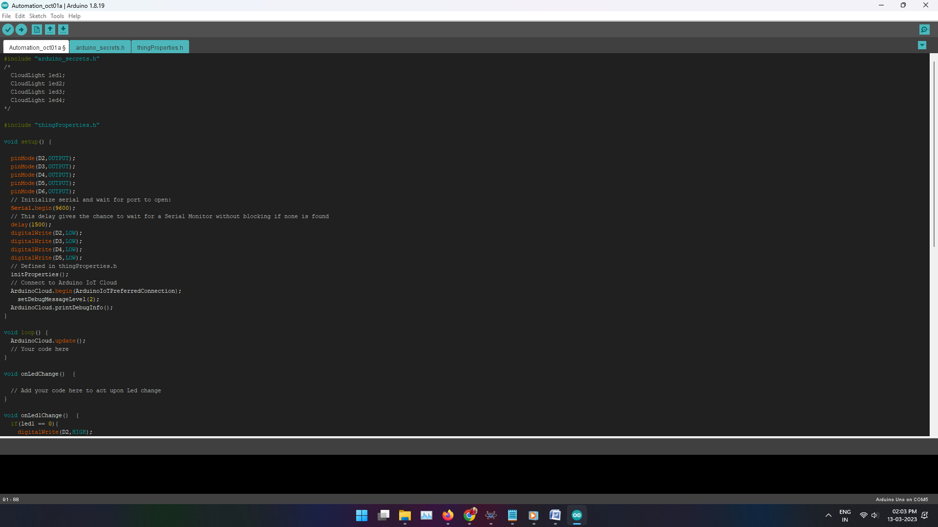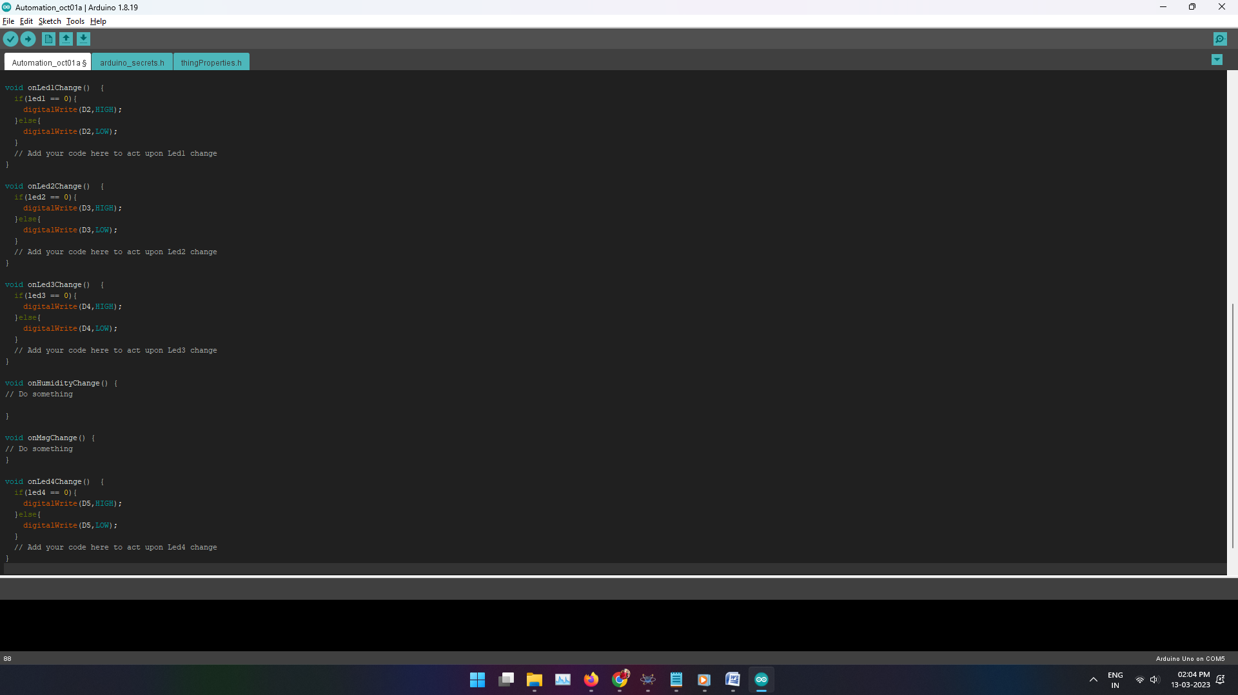
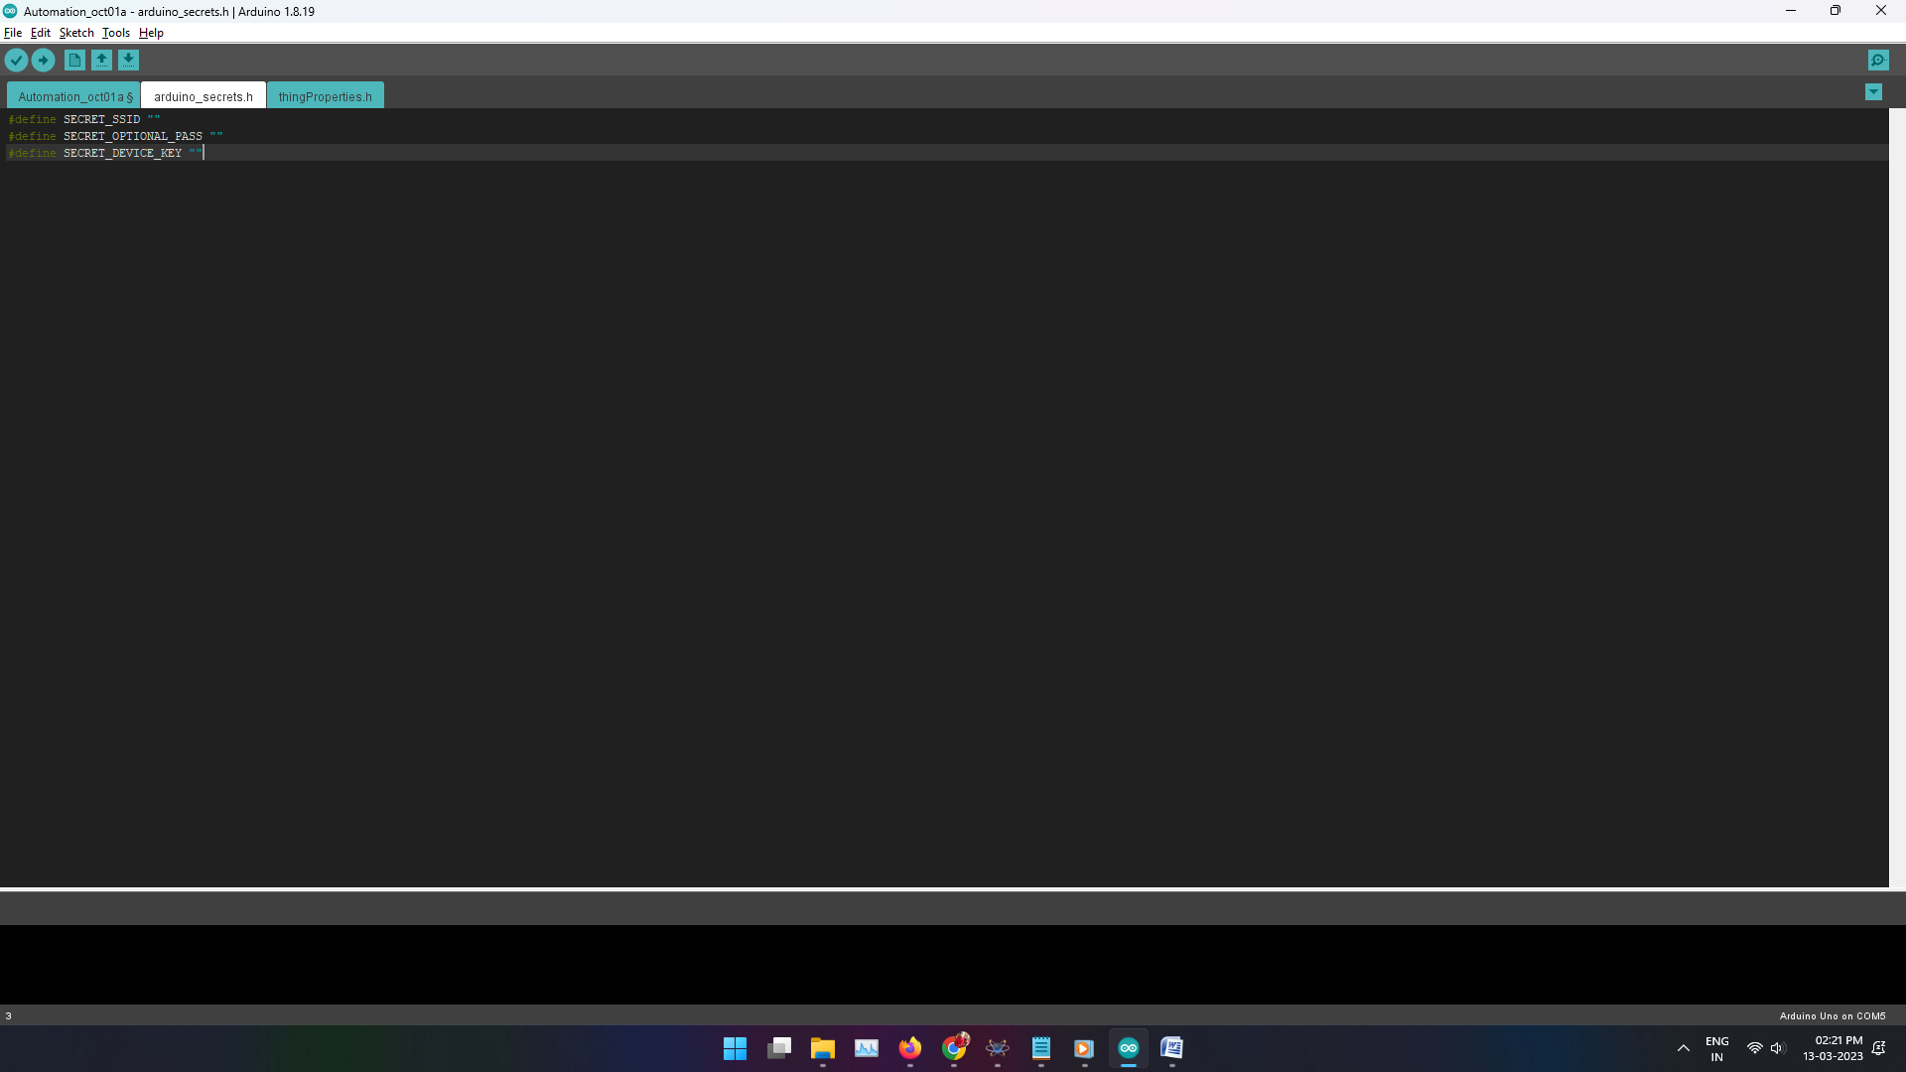
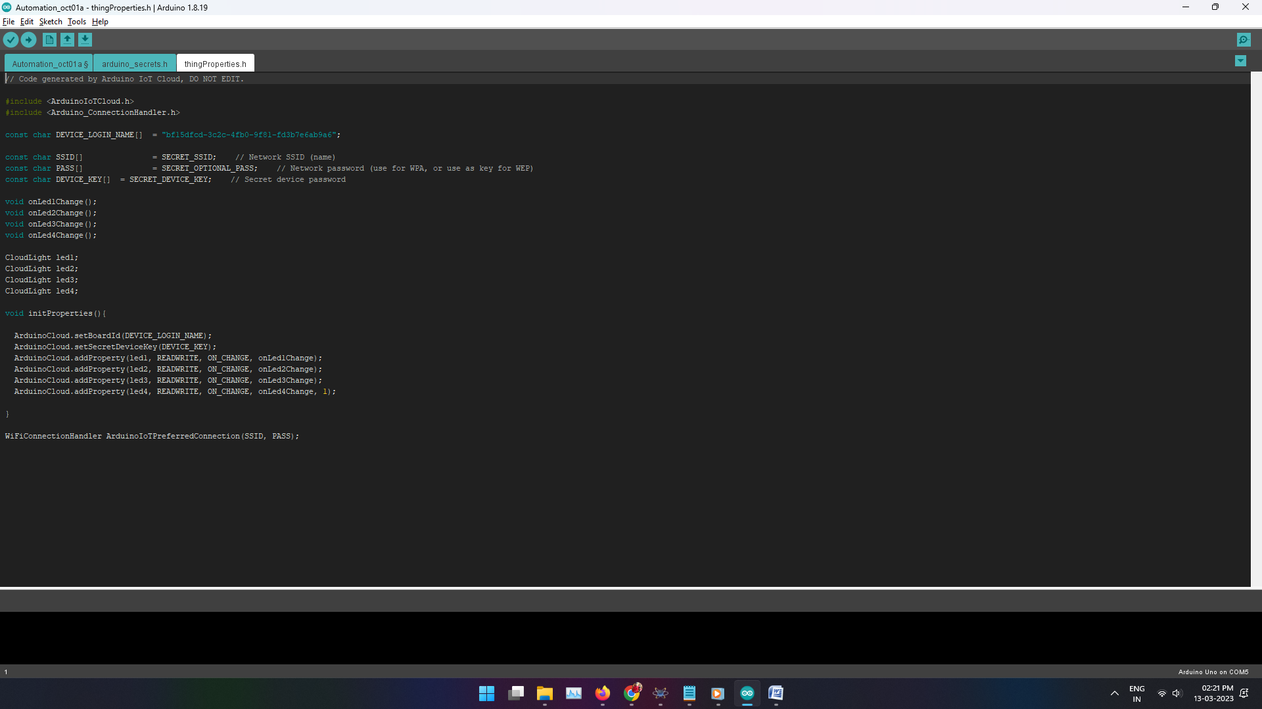
Control Panel:
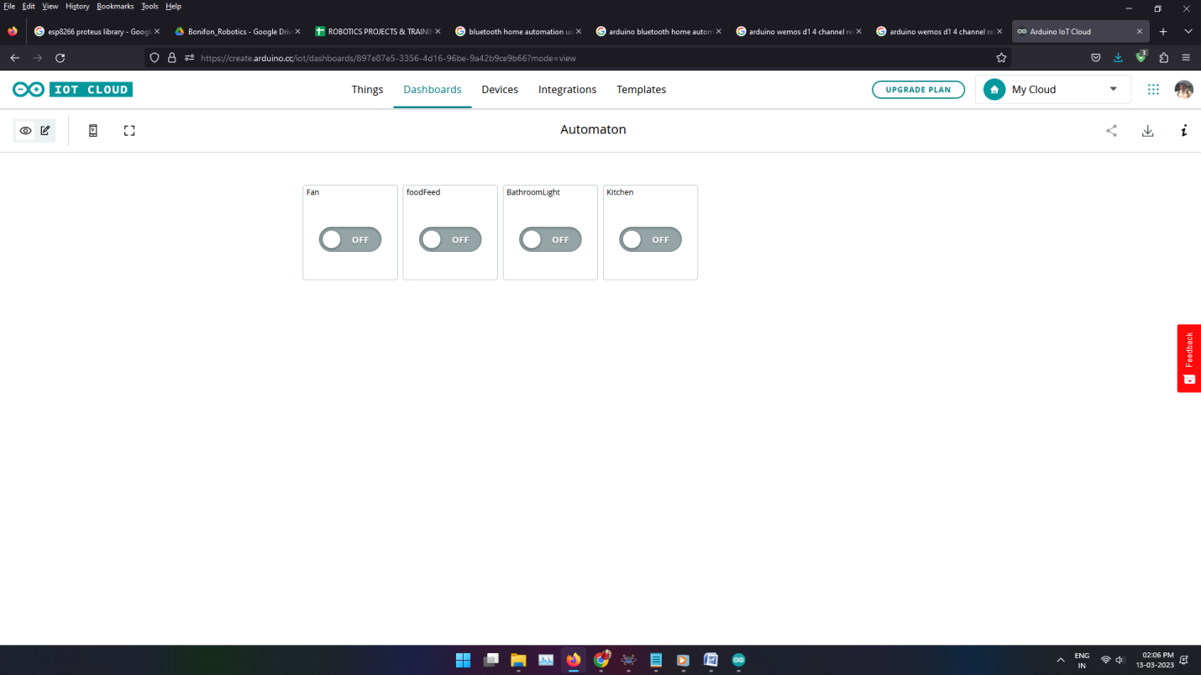
Conclusion:
We were successful in developing a system through whichthe user was given the ability to either control theirhousehold appliances through application or by using Online commands. The user is connected to the same network asthe module so exchange of signal takes place frequently.This gives users the ability to automate his home without the need to buy expensive smart appliances.

The Link reference
https://create.arduino.cc/iot/

